LAB HTML CSS RESULTS

2nd question

Animation of bar graph working as expected

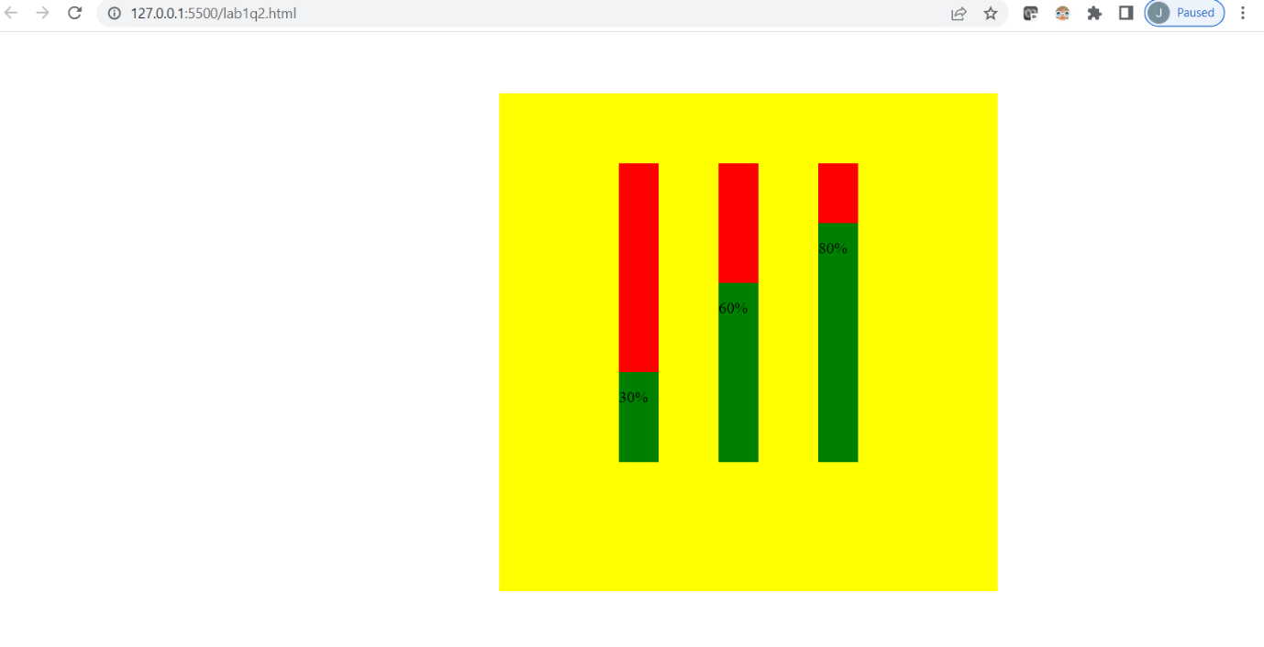

1st question

Navigation menu bar with dropdown list working as expected

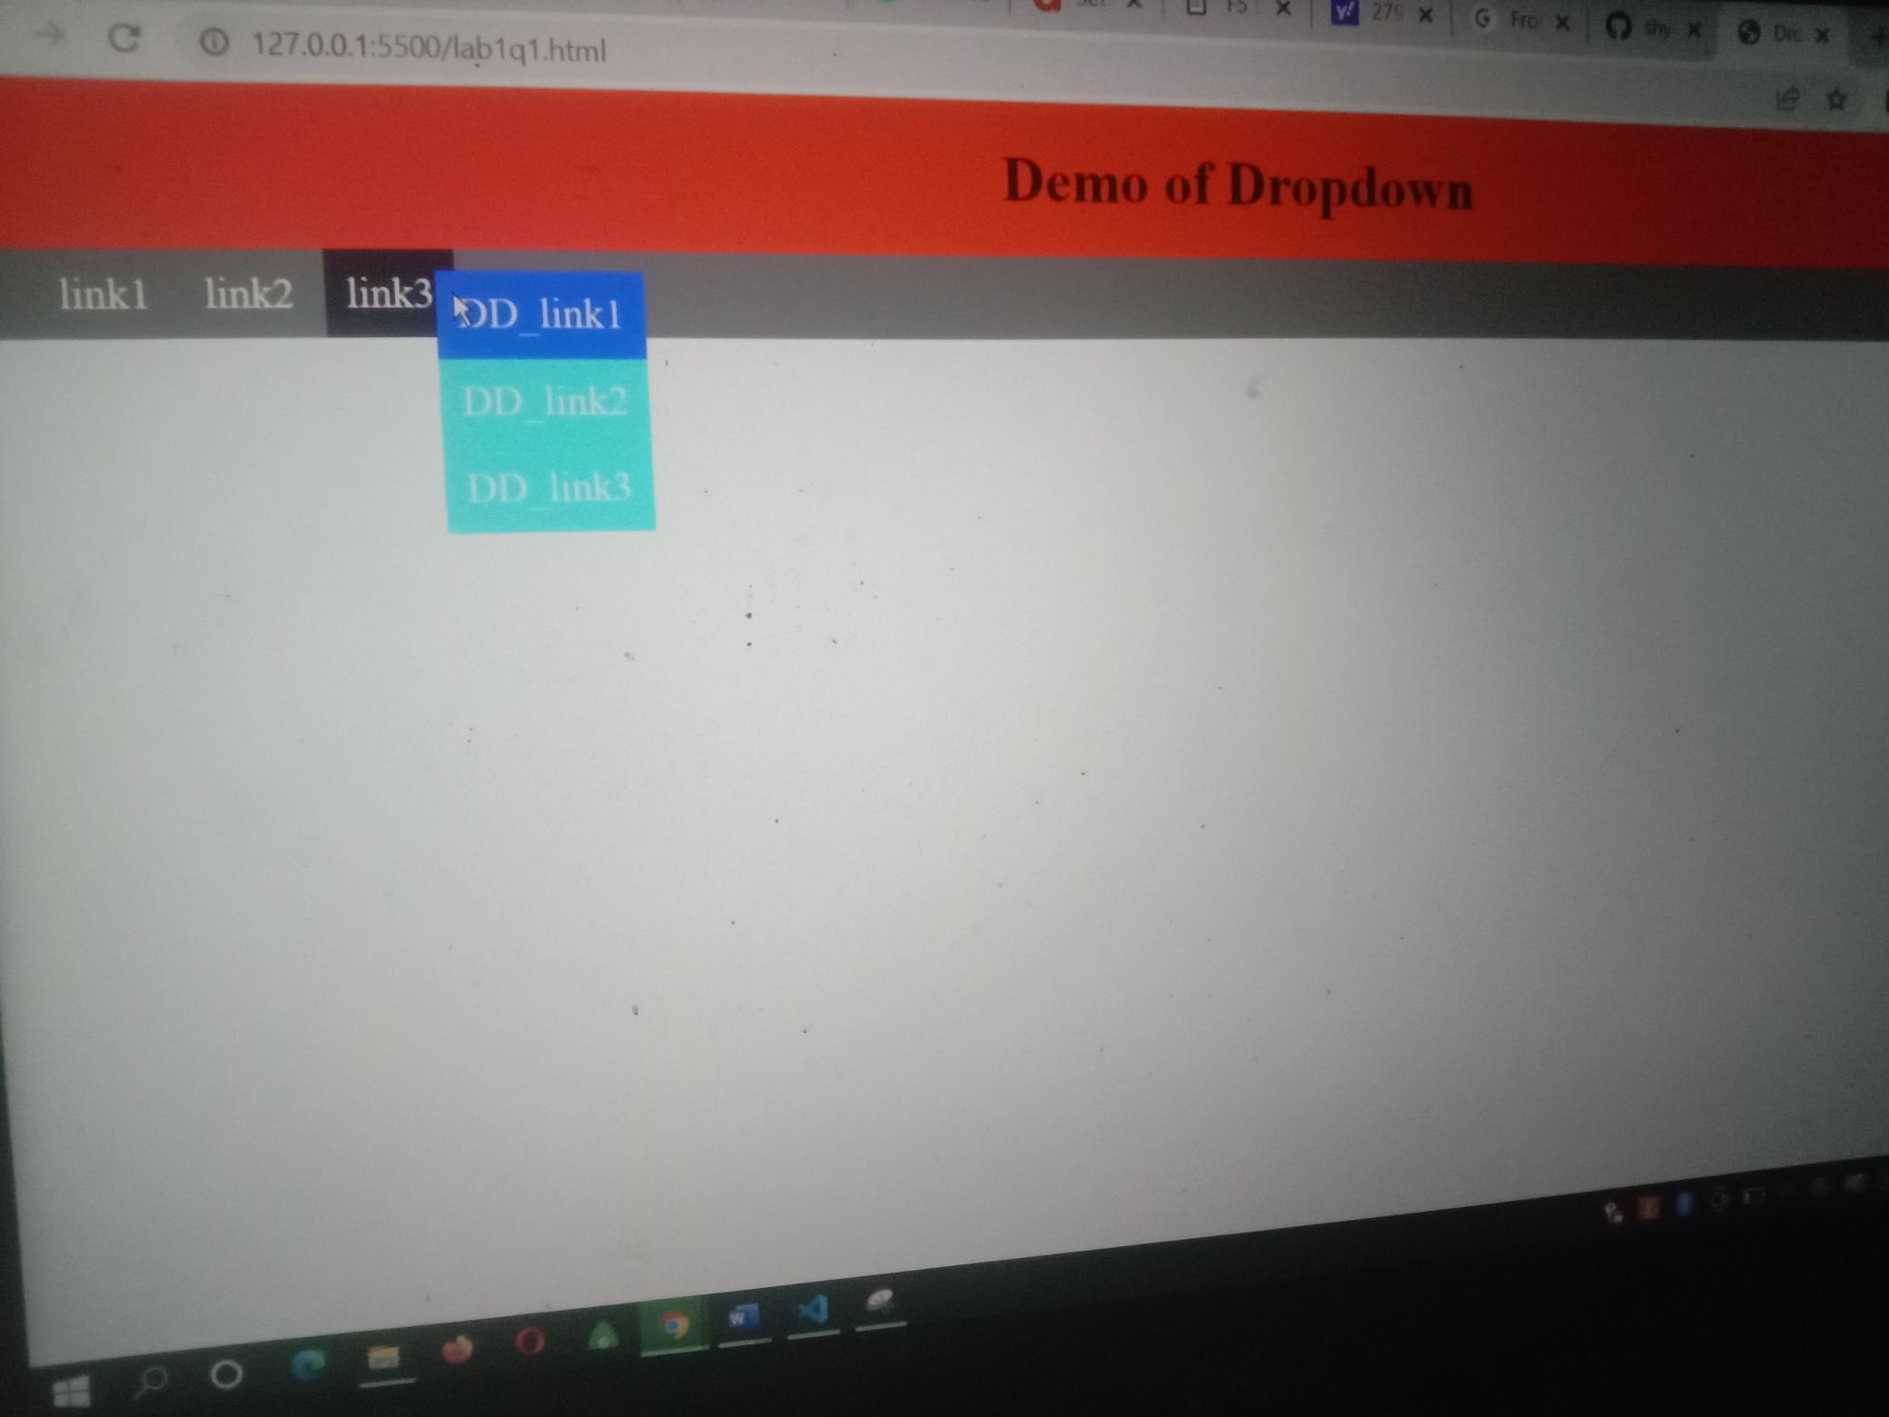

3rd question

Gmail account creation form working as expected

